Development Environment Setup

This document describes how to setup the development environment on a Windows 10 PC – this is used as default development environment.

Inhoudsopgave
Development Environment Setup 1
ESP-01 2
Extra pins for testing 2
Operating modes 2
Arduino IDE 4
JSON (build status parsing) 8
NeoPixels 9

ESP-01
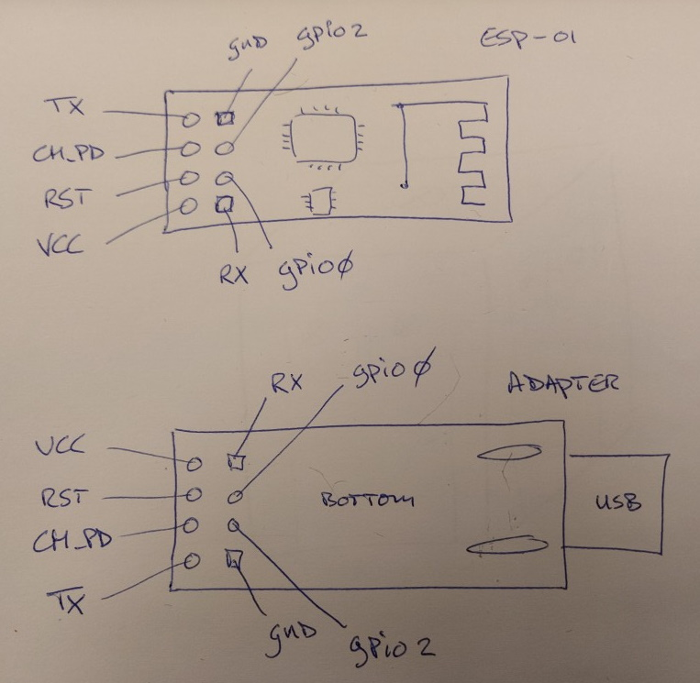
The pinout for the module and the USB programmer. Note that 1 is top, the other bottom!

Extra pins for testing
To more easily program and test with the ESP-01, a modification is made to the USB Adapter:
- Soldered a 2x4 pin header to be able to connect jumper wires.
- Soldered a jumper wire which I can disconnect. This will act as programming switch.
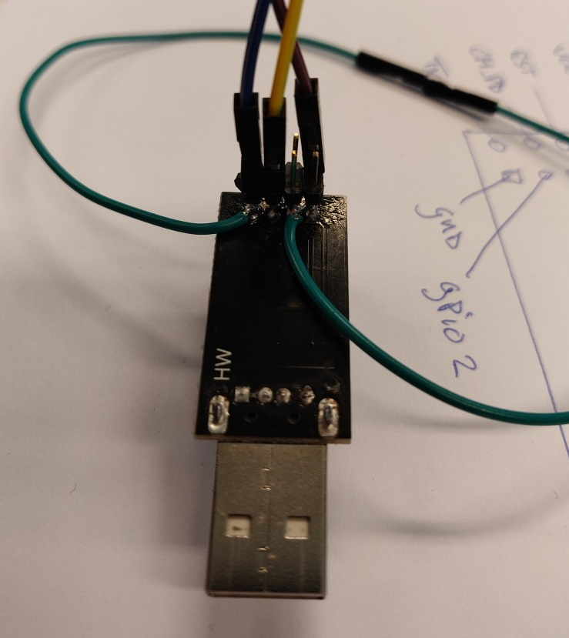
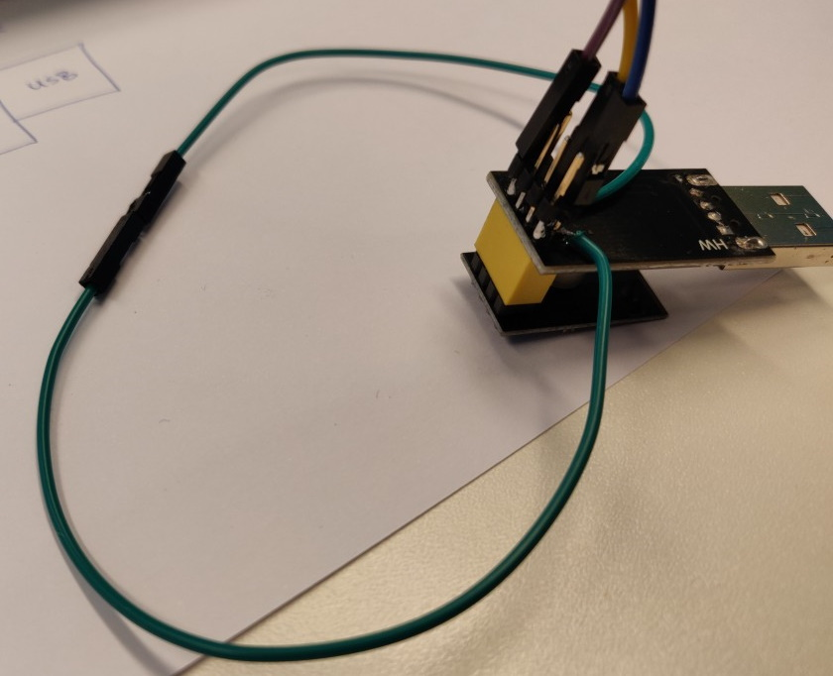

Operating modes
Program mode:
- When the wire is closed (green in the example) when connecting via USB, GPIO_0 is connected to GND and the ESP-01 starts in programming mode.
Normal mode:
- When the wire is open when connecting via USB, GPIO_0 is NOT connected to GND and the ESP-01 will start in normal mode - running the firmware on it.

Arduino IDE
The Arduino IDE is used as default IDE for source code creation. Download the Arduino IDE from the official website: https://www.arduino.cc/en/Main/Software (the windows installer, not the app)

Install the Arduino IDE.

Goto "File->Preferences". Add the following URL to"Additional Boards Manager URL":
https://arduino.esp8266.com/stable/package_esp8266com_index.json

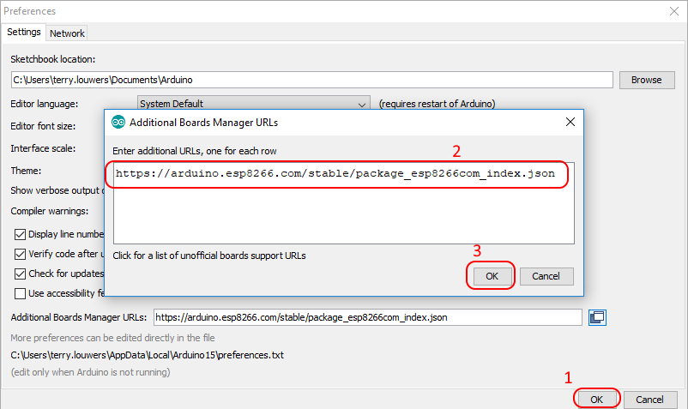
Goto "Tools->Board [...]->Board Manager".
Enter: "esp8266", then select the package and "Install".
This will take some time. Once done click "Close".

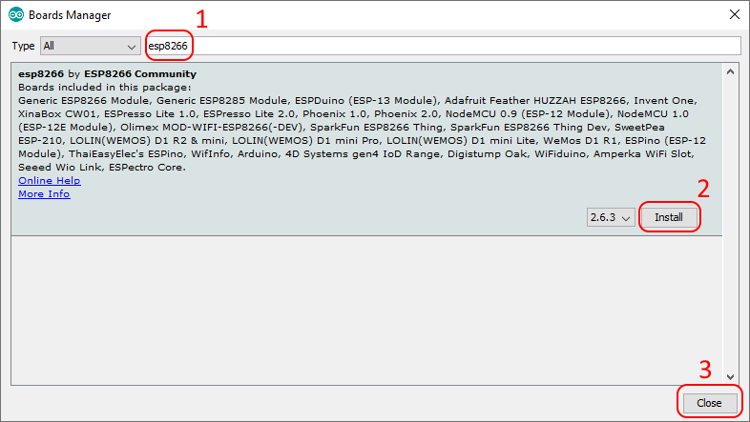
Click "Close".

Select the proper board, goto: "Tools->Board [...]->Generic ESP8266 Module".

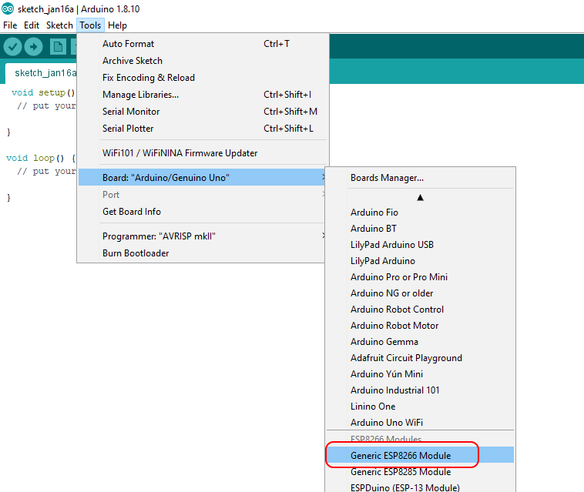

Insert the adapter with ESP-01 module. Make sure it is in "program" mode. (See: Operating modes)

Configure relevant Debug settings:

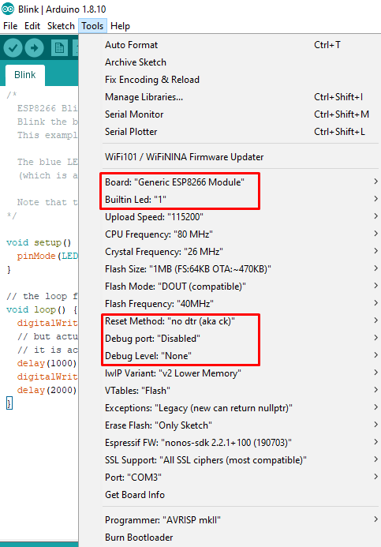
Note: the Build-in Led is at 1, debug is at None and Reset method at "no dtr (aka ck)".

Goto: "File->Examples->ESP8266", select "Blink".

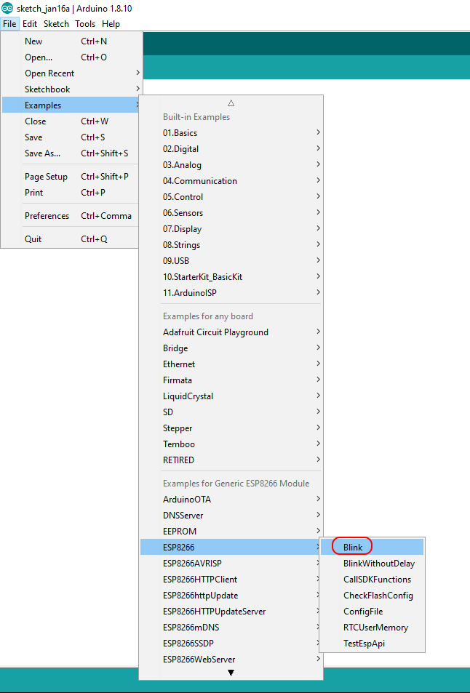
Compile and run the application, it should be downloaded to the ESP-01, after which it will run automatically. At this point the Blue led should be blinking.

Modify the code slightly by adding the "Serial.begin()" and some print statements. Note the baudrate. Since Tx is also the Blue led, we cannot toggle the led and use Serial.println() at the same time.

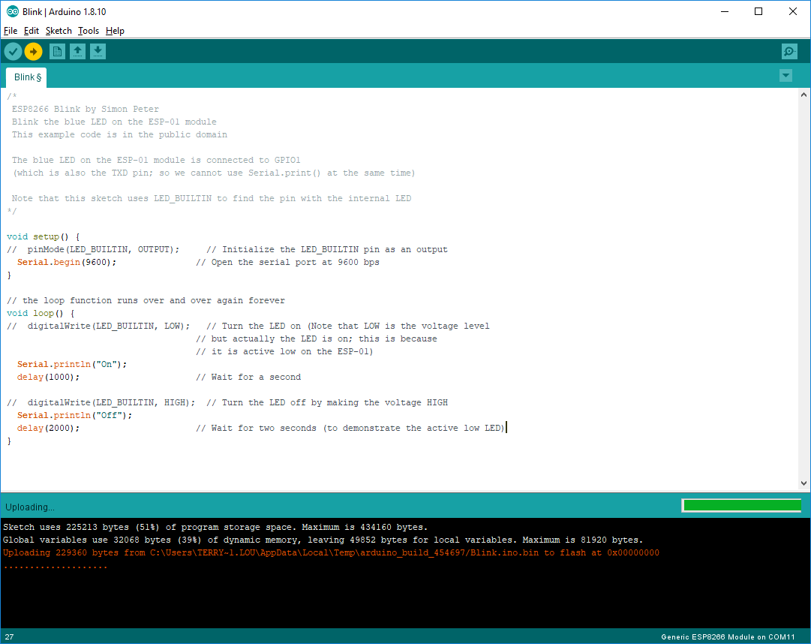
Compile and run the application, it should be downloaded to the ESP-01, after which it will run automatically.

Open the debug window: goto" "Tools->Serial Monitor". Fill the proper baudrate.

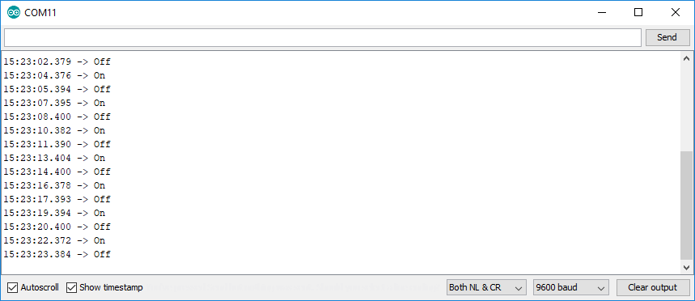
Congratulations, the development environment works!

JSON (build status parsing)

To parse the Jenkins build status we need a JSON library to assist us.

Goto: Tools->Manage Libraries...".
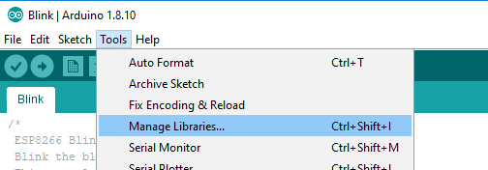
Enter: "json", then select the "ArduinoJSON" library. Click "Install".
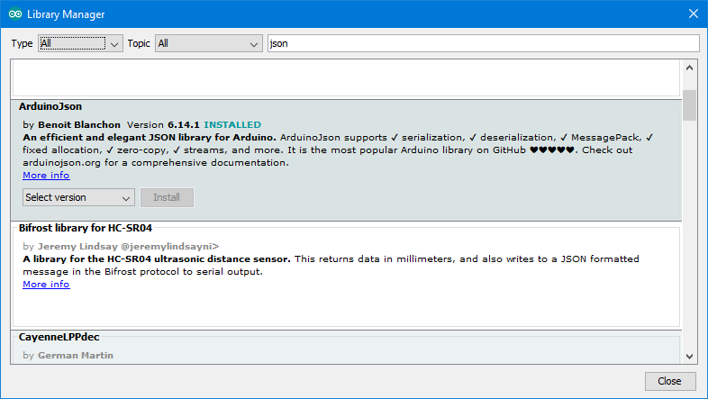
Examples are on its info page: https://arduinojson.org/?utm_source=meta&utm_medium=library.properties

NeoPixels

Goto: Tools->Manage Libraries...".
Enter: "neopixel", then select the "Adafruit NeoPixel by Adafruit" library. Click "Install".
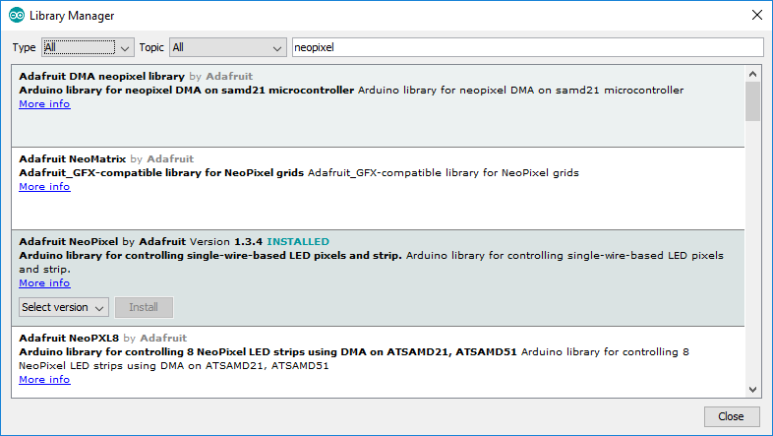
Examples are on its info page: https://github.com/adafruit/Adafruit_NeoPixel

